Devin Fromond
Lab Report
ECE 2031 L04
03 September 2025

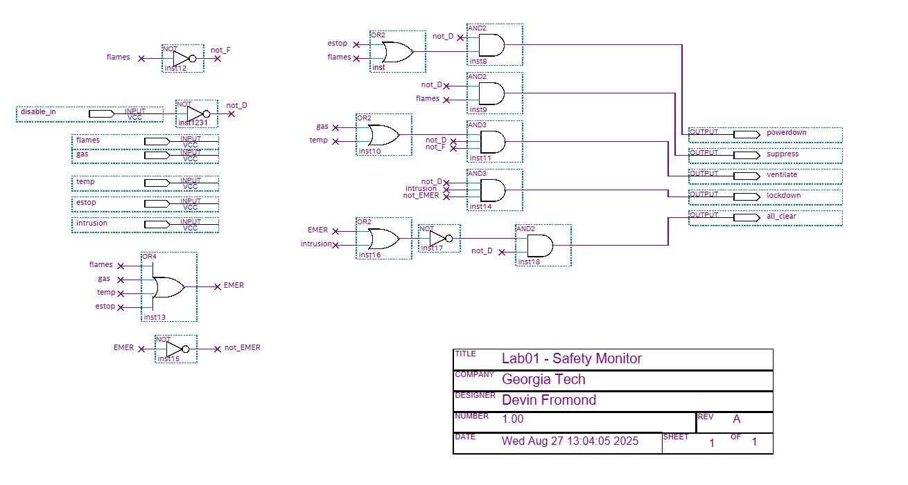
Figure 1. Schematic for the logical expressions pertaining to a safety-logic module with the outputs of powerdown (/D·(E+F)), suppress (/D·F), ventilate(/D·/F·(G+T)), lockdown (/D·I·/EMER), and all_clear (/D·/(EMER+I), where EMER=F+G+T+E and the state abbreviations are the first letter of the state as pictured on the left of the diagram.

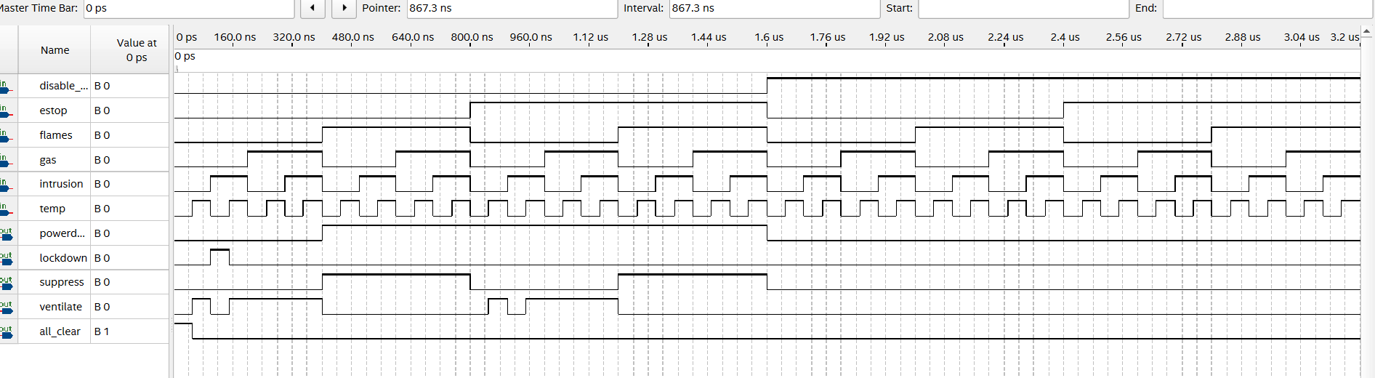
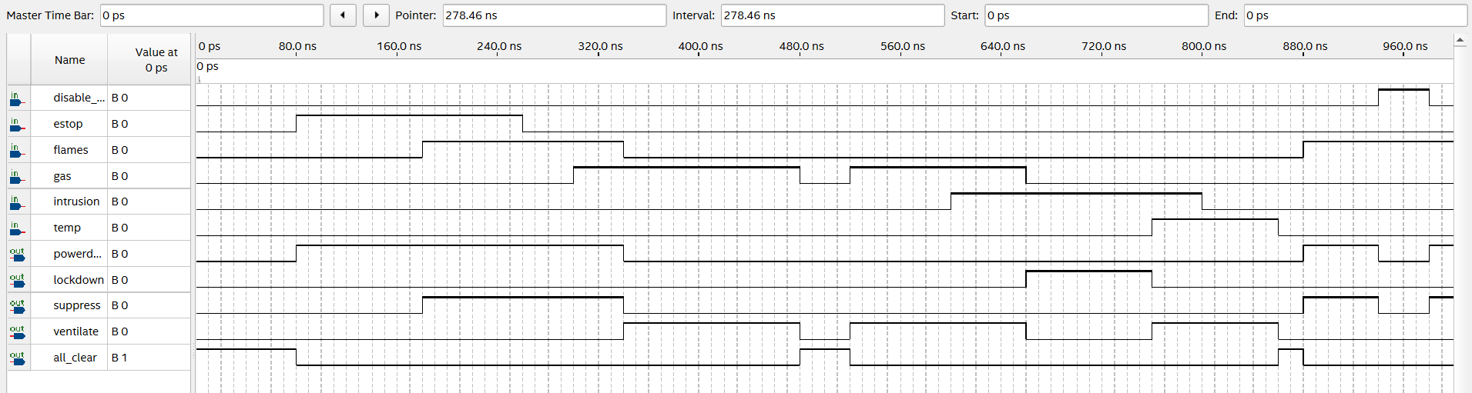
Figure 2. Waveform testing several conditions of the safety-logic module with their corresponding outputs.
Figure 3. Waveform utilizing decreasing binary periods to test all conditions of the safety-logic module
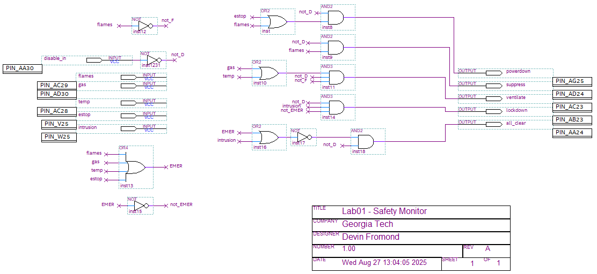
Figure 4. Schematic containing pins for an FPGA with designation 5CSXFC6D6F31C6 (identical logic to Figure 1.).

